**CS AIR GUI MANUAL TEST**

1. Run GUI.py in eclipse will show this window with buttons

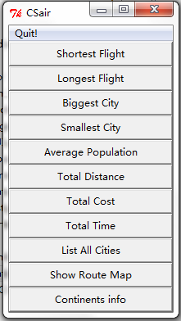

1. Click shortest flight will pop put a message box with shortest info

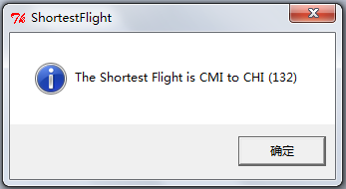

1. Same for longest flight, biggest city, smallest city, average population
2. Click total distance will show you a window with for entry box. Entry the city code.

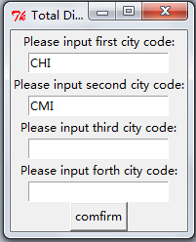

1. Then click comfirm will pop out a message box with total distance info:

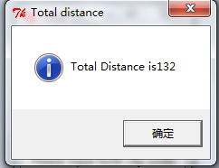

6．Click list all cities will give you a list that you can select, after select it will pops out the city info for you:

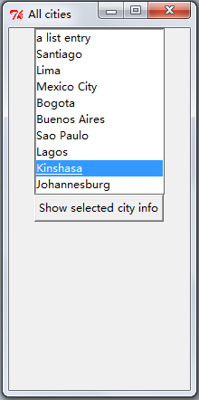

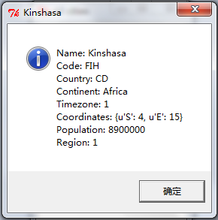

1. click show map will pops out a window show you the map:

